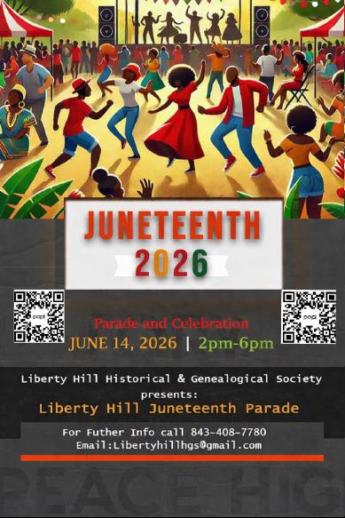

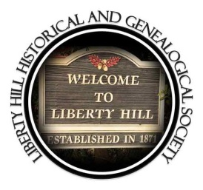

LIBERTY HILL HISTORICAL & GENEALOGICAL SOCIETY
ANNUAL JUNETEENTH PARADE & CELEBRATION
SUNDAY, JUNE 14, 2026

The Liberty Hill Historical & Genealogical Society cordially invites your organization to participate in the Juneteenth Parade and Celebration.

LINE - UP STARTs AT 12:30PM
The line – up will start at the North Charleston Transit Center located at 4565 Gaynor Ave., North Charleston, SC 29405 (see attached map). Do not be late; your location in the line-up zone may be inaccessible.
THE PARADE ROUTE (SEE ATTACHED MAP)
The Parade begins at 2:00 pm from the Transit Center on Gaynor Avenue heading North to Montague Ave, right turn onto Montague Avenue heading East toward Mixson Avenue, left turn onto Mixson Avenue heading North toward the new North Charleston Sports Complex (old Danny Jones), left turn onto Lackawanna and back onto Mixson Avenue heading South toward Montague Avenue, right turn onto East Montague Avenue heading West back thru Liberty Hill, ending the parade by turning left onto Abraham Street into Royal Baptist Church Parking Lot where floats can break down and participants can exit to the park.
CELEBRATION
Celebration following in the Park behind Felix Pinckney Community Center located at 4764 Hassell Avenue, North Charleston, SC 29405 immediately after the Parade and will culminated at 6:00 PM.
Juneteenth Committee reserves the right to photograph or videotaped to promote and publicize this event.

For Further Info call (843)408-7780
Email: Libertyhillhas@gmail.com

THE PARADE ROUTE (SEE ATTACHED MAP)
The Parade begins at 2:00 pm from the Transit Center on Gaynor Avenue heading North to Montague Ave, right turn onto Montague Avenue heading East toward Mixson Avenue, left turn onto Mixson Avenue heading North toward the new North Charleston Sports Complex (old Danny Jones), left turn onto Lackawanna and back onto Mixson Avenue heading South toward Montague Avenue, right turn onto East Montague Avenue heading West back thru Liberty Hill, ending the parade by turning left onto Abraham Street into Royal Baptist Church Parking Lot where floats can break down and participants can exit to the park.

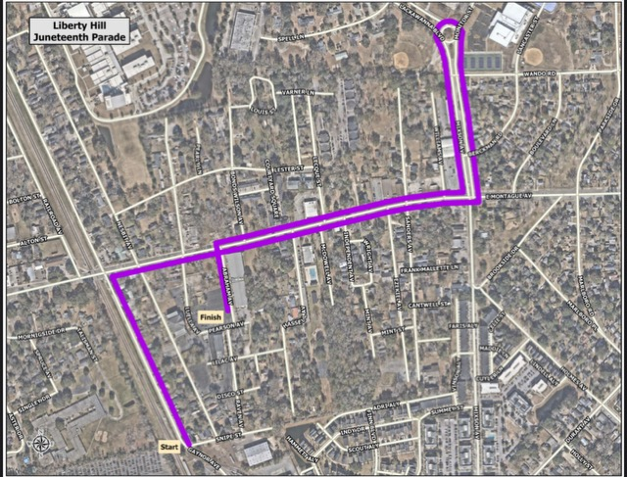
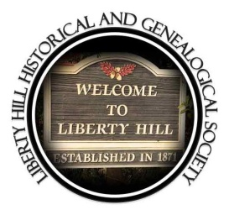

Juneteenth Parade Registration Form and Information

HOW TO REGISTER:
1. Complete the following entry form and sign the acceptance of Parade Rules and Liability Waiver
2. Return your entry form and waiver along with a $20 fee NO LATER THAN 5:00PM on FRIDAY, MAY 29, 2026
Mail: Liberty Hill Historical & Genealogical Society
ATTN: JUNETEENTH PARADE & CELEBRATION
P.O. BOX 60784
NORTH CHARLESTON, SC 29419
E-mail: Libertyhillhgs@gmail.com or CALL: (843) 408-7780

An e-mail will be sent confirming your participation in the parade after May 29, 2026.

NOTE: Application must be completed in full to be allocated a space. Any business or organization who will be represented in/on your entry or float must be included in the information you provide. Failure to abide is cause for removal from the parade.

Contact information:

Name of Organization/Group: _______________________________
Phone: ___________________
Name of org/group leader: __________________________________
Email Address:________________________
Street Address: ___________________________ City: ______________
State:_____________ Zip: ____________

Category: (Check one)

__ Business/Corporate __ Community Org or Non-profit __ Pre-School
__ Church
__ School or Marching Band __ Cheer or Dance Group __ Media
__ Fraternity __ Sorority

Music:

__ Live Singing __ Live Singing (group/choir) __ Band __ Recorded Music

Marching Units or Walking Groups:

Number of youth under age 18 marching _____ , Number of adults marching _____

Full description of unit or group
___________________________________________________________________

___________________________________________________________________

Vehicular or towed unit information:
We must know what type of vehicle(s) you are entering in the parade.

___ Small Pickup Truck ___ Large Pickup Truck ___ Car ___ Convertible ___ SUV ___ Van ____

___ Trailer (trailer is ___ feet long) ___ Car Club ___ Sling Shots

___ Motorcycle Club ___ Emergency Vehicle

___ Fire Truck ___ Golf Cart ___ Antique Car

**ALL FLOATS, VEHICLES, TRAILERS, MUST BE DECORATED **

LIBERTY Hill Historical & Genealogical Society
PARADE RULES AND LIABILITY WAIVER

1. ALL ENTRIES, INCLUDING GOLF CARTS AND CARS, MUST BE DECORATED.
2. All participants must enter the parade line- up from the Transit Center (see map).
3. No gaps in the parade line, onlookers might think the parade is over and begin walking
into the streets (making it unsafe).
4. DO NOT THROW CANDY FROM MOVING VEHICLES, ALL CANDY OR
PROMOTIONAL LITERATURES MUST BE GIVEN OUT BY WALKERS.
5. Participants cannot join or leave during the parade at any time.
6. Participants cannot get on/off floats and vehicles while the parade is in progress.
7. All children must be accompanied by an adults (walking/riding) in the parade.
8. Use of fire or open flames is not allowed.
9. No participants will be allowed to ride on the hood of any vehicle.
10. No political campaigning is allowed on any entries in the parade.
11. All participants agrees to be photographed or videotaped to promote/publicize this
event.

12. All entrants arriving in large vehicles that are not part of the parade or being dropped off must find parking. There is not room within the lineup area for these vehicles to park. Please be sure to inform ALL group participants.

APPLICANTS MUST OBSERVE ALL APPLICABLE RULES AND REGULATIONS AND FOLLOW ALL INSTRUCTIONS FROM POLICE AND PARADE OFFICIALS. THE CITY OF NORTH CHARLESTON RESERVES THE RIGHT TO REMOVE ANY ENTRANT FROM THE PARADE ANY TIME IF THE ENTRANT FAILS TO FOLLOW PARADE RULES.

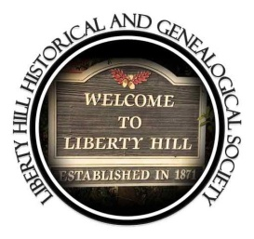

LIABILITY WAIVER:
In consideration of your accepting my entry, I hereby, for myself, my child and all participants of my entry, my heirs, executors and administrators, waiver and release any and all rights and claims for damages I, my child or entry participants may have against the Liberty Hill Historical & Genealogical Society and its representatives, successors and assigns for any and all injuries suffered by myself or my child or any entry participants at any activity sponsored by the Liberty Hill Historical & Genealogical Society. I have read in its entirety the general rules of the entry guidelines for participating in the Liberty Hill Historical & Genealogical Society Juneteenth Parade and agree to accept full responsibility of the compliance of this entry and all participants associated therewith, and for any liability inherent with this entry’s participation in the Liberty Hill Historical & Genealogical Society Juneteenth Parade. I understand that if I fail to comply with all the guidelines and rules for participation that my entry will be removed from the parade line-up.

Name of Group or Participant _______________________________________________ Date ________________________

Signature ____________________________________________________________

LIBERTY HILL JUNETEENTH FOOD VENDORS
TERMS AND REGULATIONS
Set Up 12:30 Event 3:30pm Breakdown 6:00pm

1. All vendors will set up in the park behind Felix Pinckney Community Center located at 4764 Hassell Ave.
2. All vendors must sign a Hold Harmless Agreement and returned along with application.
3. The Juneteenth Committee reserves the right to limit vendors to ensure a variety of items.
4. No alcoholic beverages may be sold.
5. Vendors must abide by SCDHEC’s guidelines and requirements. Keep your area safe, clean, neat, and prepared for inspection. Visit www.scdhec.gov for complete rules regarding Food Service.
6. Vendors setup starts at 12:30pm. Non-service vehicles must be moved to general parking by 1:30pm.
7. Vendor spaces are outdoors and must be manned at all times.
8. Vendors are responsible for managing trash in their area. Please bag trash for the city sanitation staff to pick up. Do not overstuff public trashcans.
9. Items deemed unsuitable for public display will be removed.
10. The Juneteenth Committee reserves the right to refuse an applicant that fails to meet the criteria/compliance or for damages.
11. All Damages will be paid by vendor, no refunds.
JUNETEENTH FOOD VENDORS APPLICATION
APPLICATION deadline is 5pm on Friday, MAY 29, 2026

Set Up 12:30 Event 3:30pm Breakdown 6:00pm

Business Name:______________________________________
Contact Person: ____________________________
Phone: ___________________ Email: _____________________
Street Address: __________________________
City: _____________________ State: ______ Zip: __________
Food Business License: ____________ Permit #__________________
List all items that will be sold at your booth. _____________________
_________________________________________________________
_________________________________________________________
_________________________________________________________
_________________________________________________________
___________________________________________________________________________________________________________________________________________________________________________

The non-refundable vendor fee is $50.00
Payable by check: Liberty Hill Historical & Genealogical Society
Mail to P.O Box 60784, North Charleston, SC 29419, OR
Click on the QR Code.

JUNETEENTH POP – UP APPLICATION
Application deadline is 5pm on Friday, MAY 29, 2026

Set Up 12:30 Event 3:30pm Breakdown 6:00pm

Business Name:______________________________________
Contact Person: ____________________________
Phone: ___________________ Email: _____________________
Street Address: __________________________
City: _____________________ State: ______ Zip: __________
List all items that will be sold at your booth. _____________________
_________________________________________________________
_________________________________________________________
_________________________________________________________
_________________________________________________________
___________________________________________________________________________________________________________________________________________________________________________

The non-refundable Pop - up fee is $50.00
Payable by check: Liberty Hill Historical & Genealogical Society
Mail to P.O Box 60784, North Charleston, SC 29419, OR
Click on the QR Code.

